VOWELS | DIPHTHONGS | TRIPHTHONGS | CONSONANTS
/ i: / tea | / eɪ / same | / eɪə / player | /θ/ thick
/ ɔ: / law | / aɪ / fine | / aɪə / fire | / ʃ / shoe
/ u:/ two | / ɔɪ / boy | / ɔɪə / loyal | / ʧ / chip
/ ɪ / bit | / aʊ / how | / əʊə / lower | / ŋ / ring
/ ɒ / lot | / əʊ / go | / aʊə / power | / ð / this
/ ʊ / foot | / ɪə / hear |  | / ʒ / measure
/ æ / cat | / eə / fair |  | / ʤ / jaw
/ ɜ: / earn | / ʊə / sure |  | / w/ what
/ ɑ: / far |  |  | / v / veal
/ e / bed
/ ə / above
/ Λ / bus

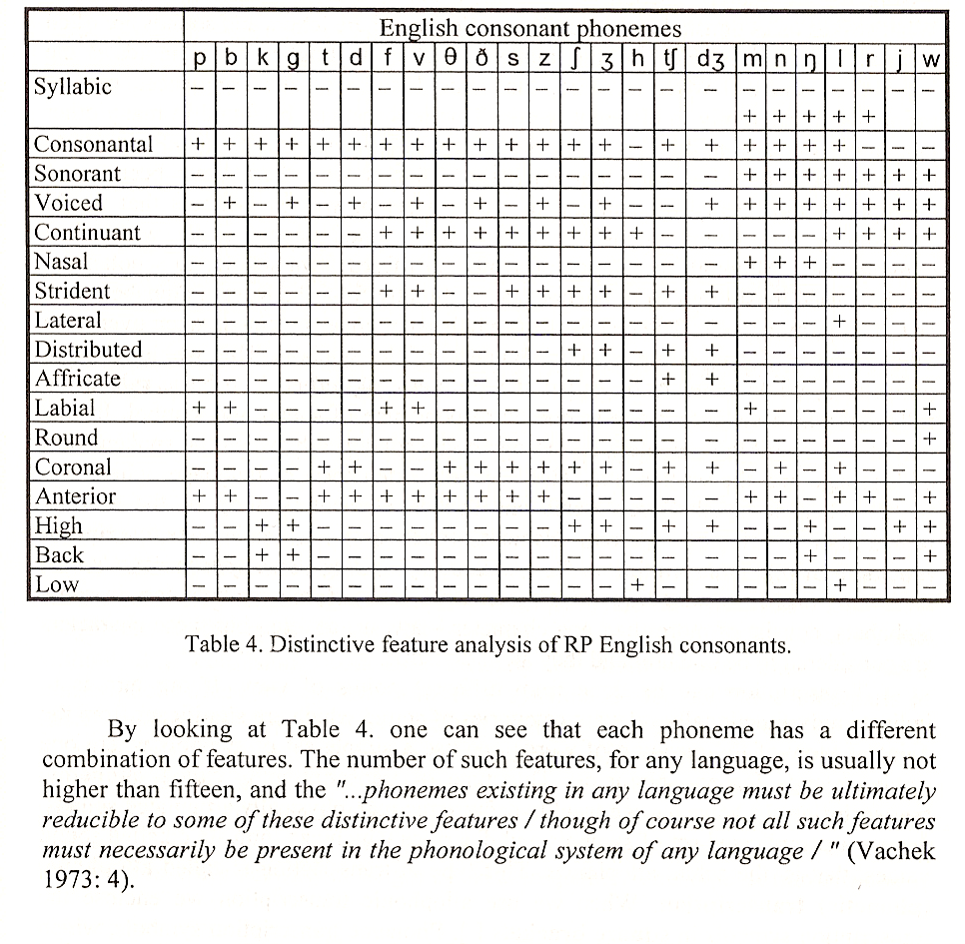

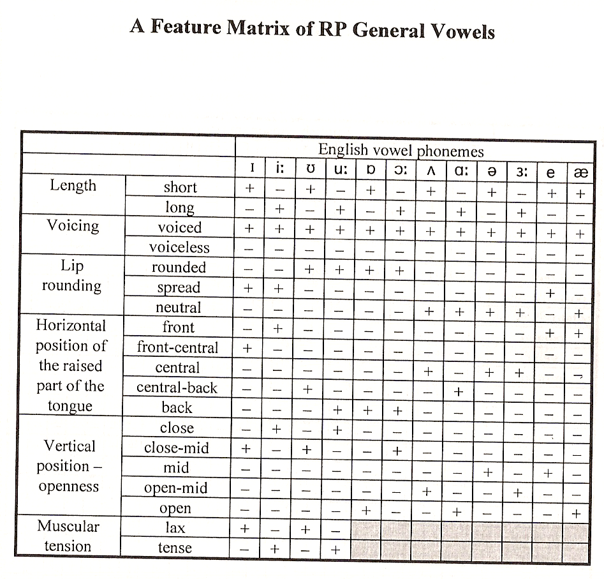

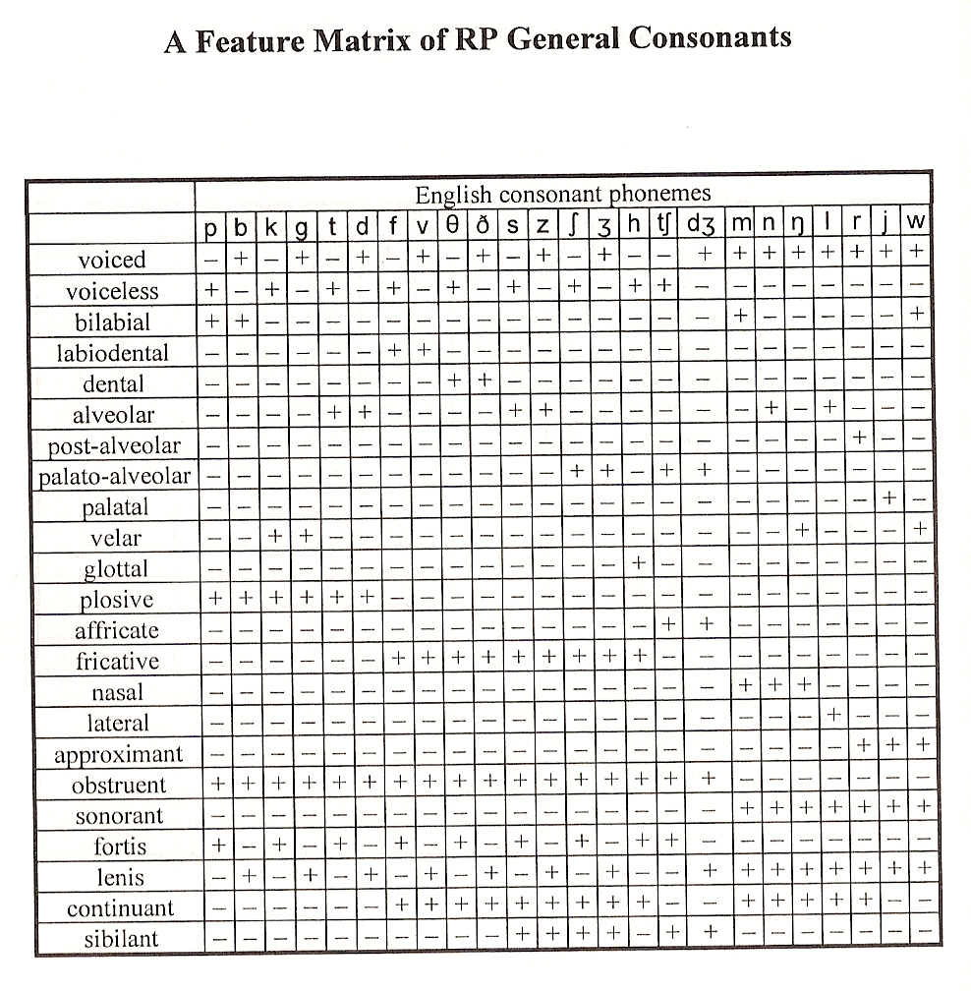

PHONETICS and PHONOLOGY I.

Speech is a string of sounds which form a continuum.
When we listen to this speech continuum we notice that some segments of it sound identical (more or less) – they repeat in different places in the continuum (e.g. nos, lano, on)
These perceptible units of speech are called speech sounds – allophones.
We normally use square brackets for it [n]

SLOVAK

lano [n] → Phoneme / n / - an abstract unit (nemení význam slova)
lanko [ŋ]
konflikt [ ɱ]
benzín [ņ]

ENGLISH

sing [ŋ] → Phoneme / ŋ / -
sin [n]
this can be changed – Phoneme / n /
conflict [ɱ]
dance [ņ]

Phonemes

- some types of speech sounds can influence the meaning of words. This groups of sounds are called phonemes
- a phoneme is a set of speech sounds with the same distinctive function in a given language
- it is the smallest contrastive unit which may bring about = to cause a change a meaning

Phonetics

- is a branch of linguistics concerned with the classification of speech sounds from the functional point of view
- it studies the abstract side of sounds of language
- the basic unit is a phoneme

Transcription

- is a method of writing down speech sounds in a systematic and consistent way
- on sound is represented by one symbol

- Phonemic Transcription – we use phonemes
- Allophonic Transcription – we use allophones (broad, narrow)

Physiological aspects of speech
Organs of articulation

The organs which we use in communication are called organs of articulation or articulators.
They can be divided into 4 main groups:

- Respiratory organs
- Phonatory apparatus
- Resonators = Resonating cavities
- Modulating organs

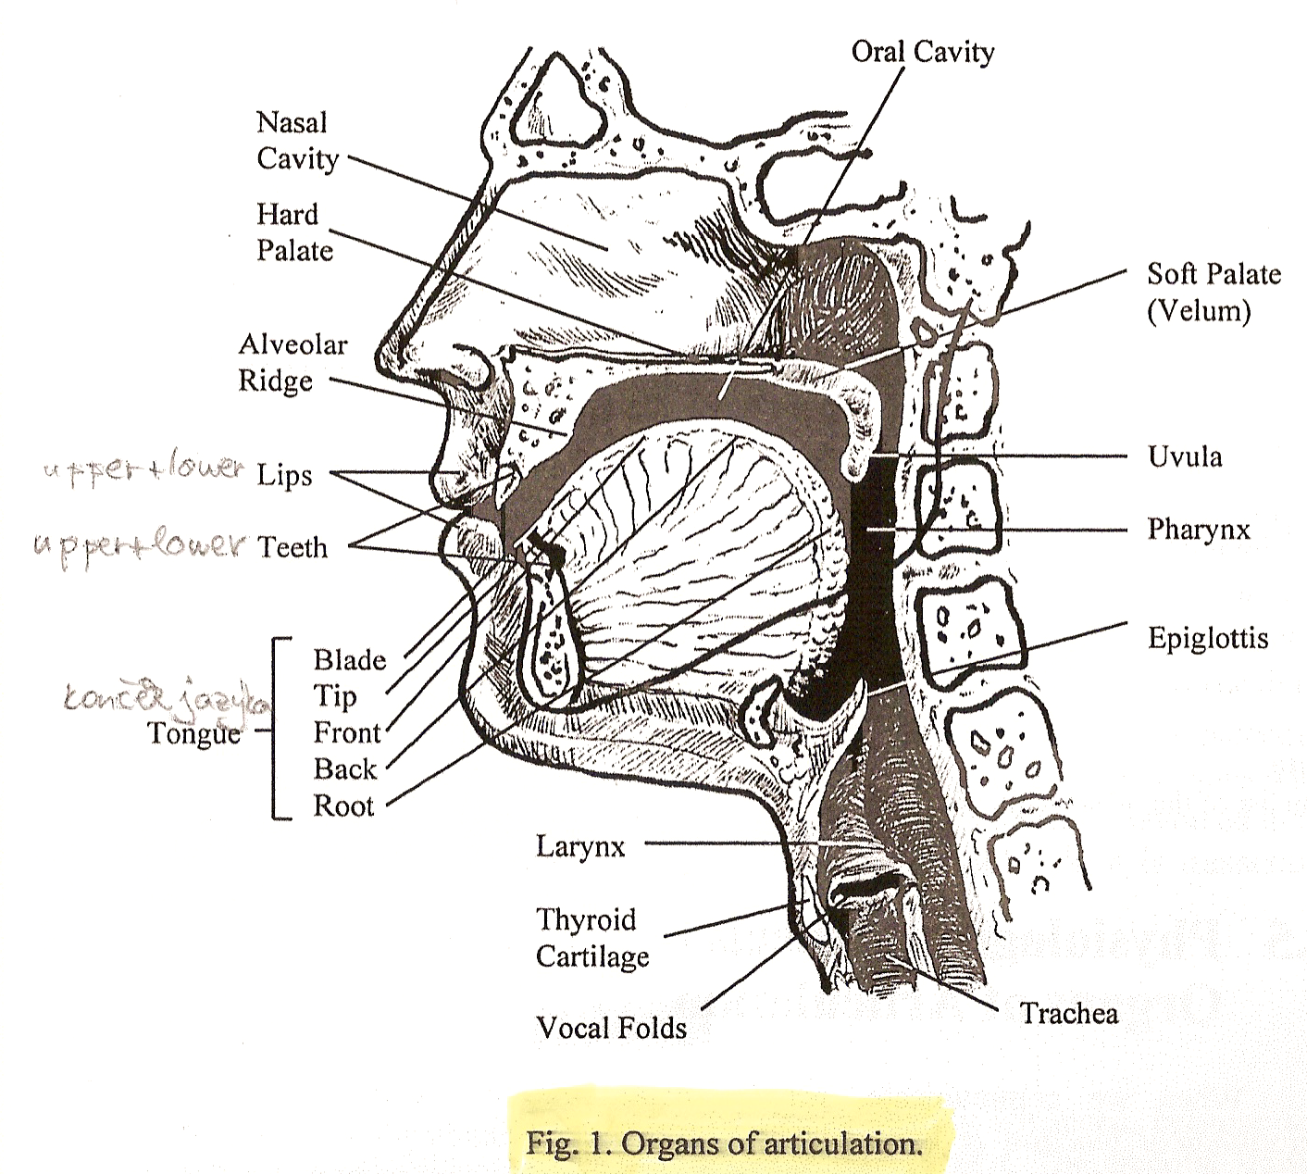

TONGUE

Tip
(lamina)
Blade
(lamina)
Front (predorsum)
Back (postdorsum)
Root
(radix)

Respiratory organs

The main source of energy form the production of speech sounds comes form the lungs.
Depending on the way the air is released form the lungs we distinguish between these air stream mechanisms:

- pulmolic – sound which are produced by the energy of the lungs, use its energy

  - egressive – the air is expelled form the lungs
– we breathe out

  - ingressive – the air is breathe in inside the lungs
– in Slovak language it is used for “híkanie”

- non-pulmolic – use some other source of energy
– these are clicks sounds

Phonatory apparators

Within larynx, there are 2 thick flaps of muscles which look rather like a pair of lips.
They can be brought together or parted through muscular tension.
This organ is called the vocal folds.
The opening between the vocal folds is noun as the glottis.
The glottis can assume different positions of openness.

There are 4 recognizable states:

- wide apart – the glottis is fully open – production of voiceless consonants
- loosely together – slightly open – production of glottal fricatives
- loosely together and vibrating – the air causes vibration – voiced sounds
(consonants and vowels)
- tightly closed – no air comes out or in – when we produce the glottal stop
(what would you do, not here – zastavenie zvuku)

The process of passing the air stream through the vocal chords resulting in audible vibration is called
voicing = phonation

Resonators

- Oral cavity
- Nasal cavity
- Pharyngeal cavity

The air stream coming from the lungs and passing through the pharynx can leave in one of these three ways:

- The soft palate may be slightly lowered. The air comes out booth through the oral and nasal cavity. In this case we produce nasalized sounds (e.g. in French)
- The soft palate s lowered and the oral cavity is blocked so the air escapes through the nasal cavity. This is where we produce nasal sounds m, n
- The soft palate is raised and blocks the nasal cavity. This is how we produce oral sounds g, f, a, b

Modulating organs

- Teeth – produced dental sounds / ð, θ /
- Alveoral ridge – alveoral sounds /s, z, t, d, r, l /
- Hard palate – we produce palatal sounds / j /
- Tongue – lingual sounds (apical, lamina, dorsal)
- Mandible – mandible sounds
- Lips – labial, bilabial or labial-dental sounds / p, b, m /
- Soft palate = velum – veral sounds / k, ch, n /
- Uvula – uvular sounds (ráčkovanie)

Acoustic properties of sounds

Every sound can be examined form the point of view of these 4 acoustic properties:

- Frequency
- Intensity
- Quality (wave structure)
- Quantity

Frequency
- is a technical term and it refers to the number of completed repetitions (cycles) of variations in air pressure occurring in the second
- it is the number of cycles that occur in 1 second
- the shorter the cycles, the higher the frequency
- the unit of frequency is the HERTZ (Hz)
- the human ear is capable of hearing the sounds ranging from 20 – 20 000 Hz
- a male voice may have an average pitch lever of about 120 Hz

Intensity
- is the amount of energy which is carried by a sound wave
- is usually measured in DECIBELS = dB
- relates to amplitude of vibration
- the bigger the amplitude, the higher the intensity

Quality
- it is the wave structure
- is that attribute of auditory sensation in terms of which a listener can judge that two sounds similarly presented and having the same loudness and pitch are dissimilar
- when vocal folds vibrate, they produce vibratory motion – the result is a glottal tone
- the glottal tone is a complex waveform – a waveform composed of several sine waves

Quantity
- is the duration of the vibration of a particular sound
- there are 2 categories of lengths:

  - absolute phonetic duration – which is measurable property milliseconds (ms)
  - functional phonological length – which can bring about a change in a meaning of a word

Acoustic aspects of speech

Sound waves

- the air around us consists of numerous tiny particles which are in constant random movement
- these randomly moving particles create certain air pressure
- when the vocal folds start vibrating, they cause fluctuations of the air pressure – the air is alternately squashed and expanded
- these fluctuations spread in all directions like ripples on a pond, and they usually become smaller as the distance form the source increases

- the wave created by compressing and expending of the air carrying sound is called a SOUND WAVE

- when the air comes out of the oral cavity ,the vibration we hear can be of 2 types:

  - Regular (periodic) vibration
  - Irregular (aperiodic) vibration

Regular (periodic) vibration

- is produced by the vocal folds providing that they are vibrating at the constant frequency and with constant intensity
- such periodic vibration manifests itself as a period wave
- perisodic waves consists of certain wave patterns that periodically (at equal intervals) repeat themselves

- these waves can be of 2 types:

    - simple periodic waves
    - complex periodic waves

- SPW – are relatively rare and they can be shown as simple sine waves (sinusovky)
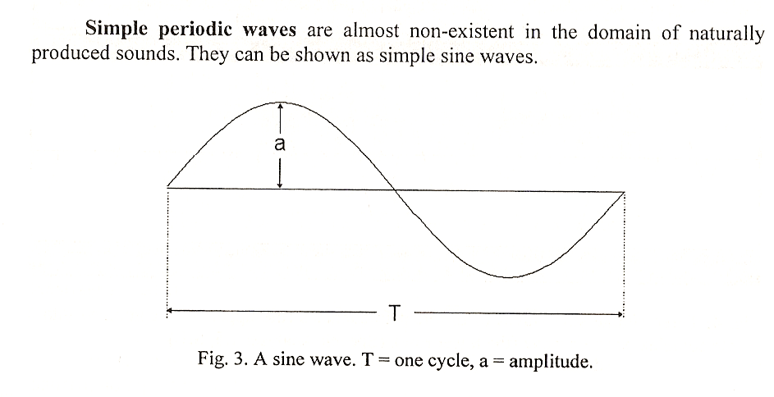

- CPW – is a wave in which several simple sine waves are combined into one single wave
– sounds produced by the vocal folds are usually complex periodic waves
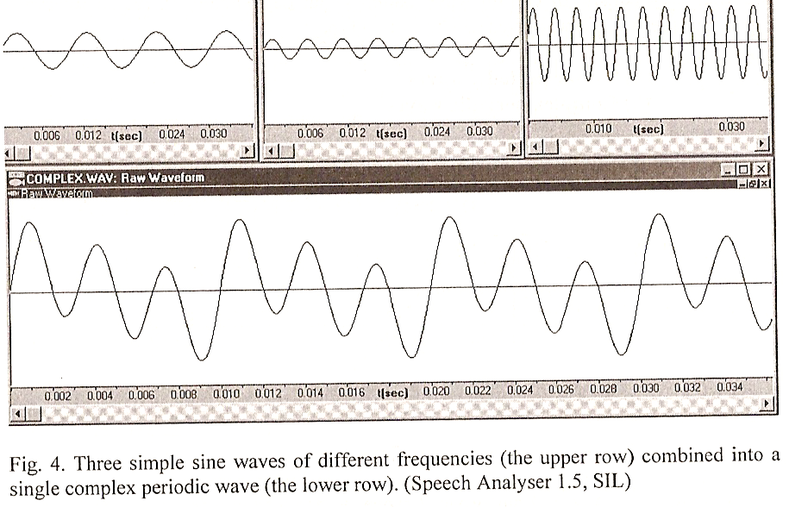

Irregular (aperiodic) vibration
- manifests itself as an aperiodic or random ware
- aperiodic waves do not show a regular periodic pattern
- they are composed of a large number of sine wave o different frequency and intensity, there is no repetition of any pattern, no regularity
- all voiceless fricatives, voiceless affricates and plosives are aperiodic waves

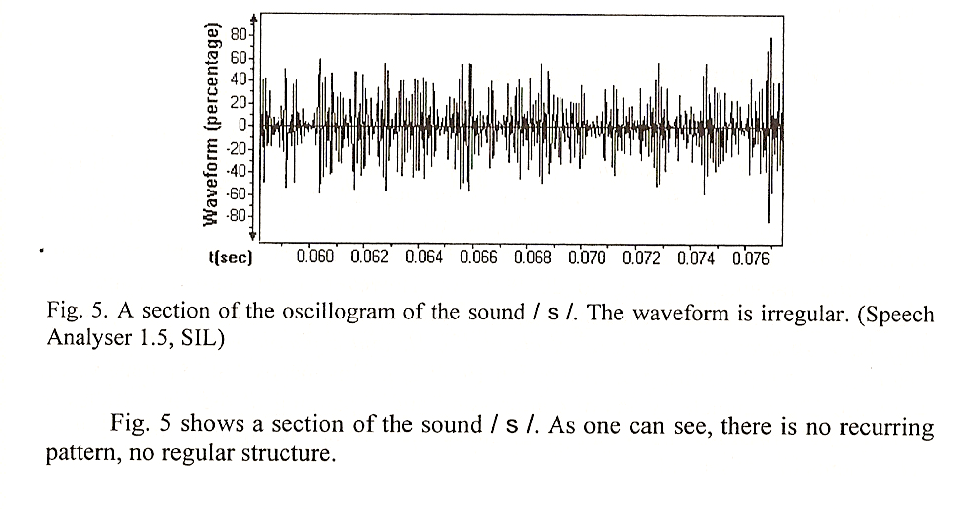

All sound in speech consists of complex periodic and low aperiodic waves

SOUND CATEGORIES

- VOWELS + SONORANTS / m, n, l, r, ŋ / – are produced by regular vibration – we can call them TONES

- VOICED OBSTRUENTS / b, d, ʤ, z / - are produced by both regular and irregular vibration
– we can call them TONES + NOISES

- VOICELESS OBSTRUENTS / p, t, s, ʧ / - are produced by irregular vibration – we can call them NOISES

VOWELS

Phonetic definition
A vowel is a sound I the production which there is no obstruction to the flow of air as it passes form the larynx to the lisp

Phonological definition
Vowels form sentence of syllables

Vowels can be divided into:

- Pure vowels = monophthongs
- Gliding vowels = diphthongs

Vowels can be shown graphically on a vowel diagram.

The vowel diagram indicates the position of the highest point of the tongue.

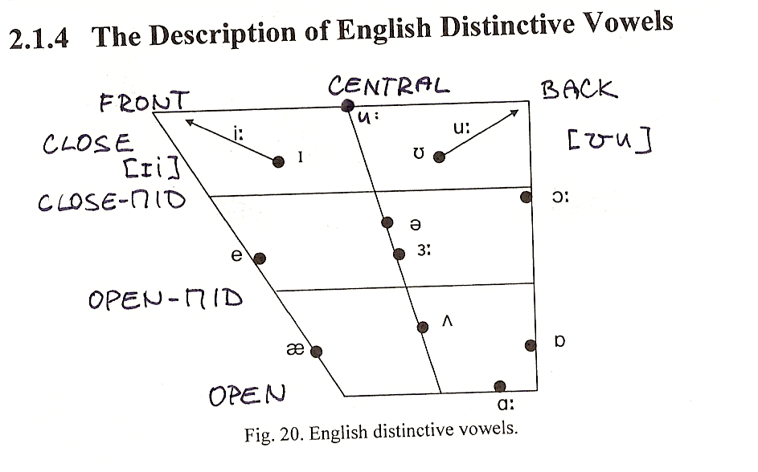

A description of vowels can be done according to:

  - the length of the vocal chord vibration

    - Phonology - short
- long

- Phonetics - very short
- short
- half long
- long

  - the position of the soft palate

- Raised – where we produce oral vowels

- Lovered – the sound might came out through oral cavity or nasal cavity (oral or nasalized vowels)

  - the shape of the lips

- Rounded

- Spread

- Neutral / ə /

  - the horizontal movement of the tongue

- Front
- Central
- Back

  - the vertical movement of the tongue (different degrees of openness)

- Close
- Close – mid
- Open – mid
- Open

  - the muscular tension of the tongue

- Lax vowels / ɪ / / ʊ /
- Tense vowels / i: / / u:/

Phonological length

Phonological English vowels are short and long

There are minimal pairs:

sit – seat
cut – cart
full fool
don – dawn
beat – but
for – fur

Phonetical length

Phonetically the length of English vowels depends on the type of the following sounds:

- voiceless consonants decrease the length of short and long vowels (sot=short, sort=long)
- voiced consonants do not influence the length of short and long vowels

The total duration of the short vowels and a voiced consonant equals the total duration of the short vowel and the voiceless consonant.
The same applies to long vowels.

DIPHTHONGS

Phonetically
A diphthong is a complex speech sound beginning one vowel sound and moving to another vowel position within the same syllable.

Phonologically
Diphthongs are those units which form sentence of syllables.

According to the type of sounds they consist of – diphthongs can be divided into:

1. CLOSING

- ending with / ɪ / - / eɪ / / aɪ / / ɔɪ /
- ending with / ʊ / - / aʊ / / əʊ /

2. CENTRING – ending with / ə / - / ɪə / / eə / / ʊə /

The length and prominence of English diphthongs

- when the first part of the D. is longer and more prominent, the D. is said to be falling
- when the second part of the D. is longer and more prominent, the D. is said to be raising
- when stressed, all English D. are falling
- in an unstressed position / ɪə / and / ʊə / are rising, and the rest of English D. are falling

CONSONANTS

Phonetically
A C. is a speech sound produced by a partial of complete obstruction of the air stream by any of the various speech organs

Phonologically
C. are those segments which occur ate the edges of syllables

Consonants can be described according to:

      - the source of the energy

- from the lungs – pulmonic
- not from the lungs – non-pulmonic (clicks)

      - the direction of the air stream

- out of the lungs – egressive
- breathing the air in – ingressive

      - the vocal folds activity

- active – voiced
- not active – voiceless

      - the position of the soft palate

- lowed – nasal C. (m, n, ň)
- raised – oral C. (all others)

      - the place of articulation

- the lips are used – bilabial sounds (b, m,
- the lips and teeth are used – labiodental sound (v, f, ɱ)
- dental sounds [θ]
- the tongue touches the alveolar ridge – alveolar (e, d, z, s)
- the tip of the tongue is curled backwards – post-alveolar sound / r /, [ ɹ ]
- palato-alveolar / ʧ, ʃ, ӡ, ʤ /
- palatal sounds / j /
- the back of the tongue touches the soft palate – velar sounds / k, g, ch, ŋ /
- glottal consonants – voiced and voiceless /h/, voiceless /j/

      - the manner of the articulation

- occlusives – produced with a complete occlusion /m, t, d /
- semi-occlusives – formed first by a occlusion + constriction [ ʧ ] [ts]
- constrictives – formed with a narrowing with a friction (šum) [s, z, š, ž, f, v, h]
- approximants – also formed with a narrowing but without a friction [ j ] [ w ] [ ɹ ]

      - the articulating organ – depending on the active articulating organ used we distinguish these cassis of C.:

- labial (bilabial, labio-dental)
- lingual
  - apical (len konček jazyka)
  - laminal (tvorené čepeľou)
  - pre-dorsal (predná časť – ť, ď, ň, j)
  - post-dorsal (zadná časť – k, g, h, ch)
  - radical (koreňové – abrabské, hebrejské)
- glottal
      - the auditory impression – according to the presence or absence of a noise component

- obstruents – noise (+tone) consonants

- plosives /ď, ť, ň /
- fricatives (šum)
- affricates (and their combinations – č, ž, c, dz)

- sonorants / resonants – these are tone C. – only composed of tones but no noises

- oral / j, w, r, ɹ /
- nasal / n, m, ň /

      - the muscular effort

- fortis – are articulate with strong muscular effort = voiceless C.
- lenis – are articulate with a lithe muscular effort = voiced C.

      - length

- long and short C.
- continuants (mmm, sss) and non-continuants (t)

PRONUNCIATION OF SUFFIXES

INFLECTIONAL SUFFIXES

→are morphemes which express certain grammatical relationships such as

- the plural
- the present participle
- the past tense
- the third person singular present tense
- the possessive case

work - s
do not change the lexical meaning of the word
- ing
- ed

→ STEM – is that part of the word form which remains when all inflectional affixes have been removed
– chars – stem + inflectional S.
– wheel chairs – stem + inflectional S., but contains 2 roots

→ SOUNDS – the pronunciation of inflectional S. in English follows certain rules:

1.) I.S. -ed

- this S. is added to regular verbs to from the past tense

- the pronunciation of this S. follows these rules:

- if the stem ends in /t/ or /d/ - we add /id/ in pronunciation /bli:t/ → /bli:t ɪd/
- if the stem ends in a vowel – we add /d/ in pronunciation /fri:/ → /fri:d/
- if the stem ends in a voiceless C. except /t/ - we add /t/ in pronunciation /lɪk/ → /lɪkt/

- when at the end there is a voiced C – the suffix must be voiced as well – except /t/ and /d/

2.) I.S. –s & -´s

- the S. –s is found in regular plural and the third person singular in present tense where as the S. -´s
forms the possessive case or the so called -S Genitive

- the pronunciation of the suffixes follows these rules:

- if the stem ends in a sibilant (sykavka) /s, z, ʃ, ʒ, ʧ, ʤ / - we add /-iz/ in pronunciation /pleɪs/ → /pleɪsɪz/
- if the stem ends in a vowel or any non-sibilant voiced consonant – we add /z/ in pronunciation /fləʊ/ → /fləʊz/
- if the stem ends in any non-sibilant voiceless consonant – we add /s/ in pronunciation /kɒf/ → / kɒfs/

- with regular plurals and some word ending /s/ or /z/, the Genitive is expressed by apostrophe only.
In such cases the pronunciation follows these rules:

- fixed expressions with “for … sake” are pronounced with zero suffix /fə,gʊdnəs´seɪk/
- regular plurals in the Genitive are pronounced with zero suffix /bɒɪz/
- Greek names of more than one syllable in Genitive are pronounced with zero suffix /´sɒkrəti:z/
- some names ending in the voiced sibilant /z/ take /iz/ in the Genitive /´dɪkɪnzɪs/

3.) Suffix -ing

- the suffix -ing is both an inflectional suffix and a derivational suffix
- this suffix is added to English verbs to create continuous forms of verbs, verbal nouns, or adjectives

- the pronunciation of this suffix follows these rules:

a) if the stem ends in a consonant, or any of the vowels /i:, u:, ɔ:/ or diphthongs other than / ɪə , eə ,ʊə /
- we add / ɪŋ /

b) if the stem ends in any of the following / ɑ:, ɔ:, ɜ:, ə, ɪə, eə, ʊə/ - we add /rɪŋ/

DERIVATIONAL SUFFIXES

→ are morphemes which usually change the word class of the roots they are attached to

→ by adding a derivational suffix to a root, we create a new lexical word (lexem)

e.g. love → lovely
do → redo
hope → hopeful

→ pronunciation of the most problematic derivational suffixes:

- -able /əbl/ - /breɪk/ → /´breɪkəbl/
- -age /ɪʤ/ - /breɪk/ → /´breɪkɪʤ/
- -en /n/ or /ən/ - /lu:s/ → /´lu:sn/ + /fɔ:l/ → /fɔ:lən/
- -ful /fl/ - if it is an adjective - /feɪθ/ → /´feɪθfl/
/fʊl/ - if it is a noun - /fu:m/ → /´ru:mfʊl/
- -less /ləs/ - /help/ → /´helpləs/
- -ment /mənt/ - /peɪ/ → /´peɪmənt/
- -ness /nəs/ - /´ləʊnlɪ/ → /´ləʊnlɪnəs /

SYLLABLE, SYLLABIC CONSONANTS

Syllables
- Syllables can be defined as units of spoken language consisting of a single uninterrupted sound formed by a vowel (monophthong, diphthong, tripthong) of a syllabic consonant, or of either with one or more consonants
- it is a unit containing on main peak of sonority (má jeden vrchol zvučnosti)

c
cc
ccc
c
v
consonants
cc
ccc

monothongs
diphthongs
tripthongs

this is the peak of sonority

skr ei pt
c a t

Syllabic consonants
- a SC is a consonant functioning as the syllabus nucleus (ako jadro slabiky)
- can be found mainly in unstressed syllables of roots
- they occur after another consonant and usually depend on the type of this preceding consonant
- the main problem which arises here, and which applies to all SC, is the realisation of the sequence containing the SC

- there are 2 possibilities and graphically they could be expressed like this:

- /c + ə + c/ - there is no SC /´mΛtən/
- /c + SC/ - šva vypadne, vzniká slabikotvorné „n“ /´mΛtn/

L – Syllabic /l/

- in connected rapid speech, the sequence /consonant + syllabic l/ is always preferred to the sequence /c + ə +l/
- always use syllabic /l/ - /´kΛpl/

N – Syllabic /n/

- if the ending sequence of polysyllabic words begins with any consonant except /l, m, n, nt, nd/, the sequence /c + syllabic n/ is preferred - /´mΛtn/
- if the ending sequence of polysyllabic words begins with any of the consonants /l, m, n, nt, nd/, the sequence /c + ə + n/ is used - /´sΛlən/
- samohláska má vždy vyššiu sonoritu a preto preberá vrchol znelosti

M – Syllabic /m/

- if the ending sequence of polysyllabic words begins with any of the following consonants / θ, ʃ, ð, s, z /, the sequence pattern /c + syllabic m/ is preferred - /´ænθm/
- len pri veľmi pomalej reči je zreteľná šva
- if the ending sequence of polysyllabic words beginns with a consonant other than / θ, ʃ, ð, s, z /, the sequence pattern / c + ə + m /is used - /´ælbəm/
- if a word ends in the sequence /pən/, /pņ/, /bən/, /bņ/ - this sequence can, as a result of simultaneous ellysion and assimilation change onto /pm/ or /bm/
- happen = /´hæpən/ - very slow articulation, /´hæpņ/ - normal speech, /´hæpm/ - fast, informal speech

Ŋ – Syllabic /ŋ/

- this SC occurs in English only as a result of simultaneous ellysion and assimilation
- if a word ends in a sequence /kən/, /kņ/, /gən/, /gņ/ - this sequence can change into /kŋ/ or /gŋ/
- thicken = /´θɪkən/ - very slow, /´θɪkņ/ - normal, /´θɪkŋ/ - very fast

ELISION WITHIN THE WORD

→ it is the emission of sounds
→ it occurs under the influence of increased tempo, the sound’s quality, it’s position in the word, the quality of
the neighbouring sounds and the speakers style

Elision of vowels
- if the penultimate syllable of simple and derived sounds contains / ɪ / , / ə / and it is created by syllable with the primary stress, the / ɪ / , / ə / tend to be elided - /´pɒs(ɪ^{ə})bl/
- if a pre-penultimate syllable of simple and derived words contains / ɪ / , / ə / and it is preceded by a syllable with the primary stress, the / ɪ / , / ə / tend to be elided - /´dɪf(ɪ)kltɪ/
- words ending in / ʊərɪ/ have a tendency to drop either / ʊ /, / ə / or / ʊə / in rapid connected speech /´ʤænj(ʊə)rɪ/
- the initial sequences /c+ə+l/ and /c+ə+n/ tend to drop the vowel /ə/ in rapid speech, and the primary stress is moved to the beginning of the word - /k(ə/´lɪʒn/ → / ´klɪʒn/
- the word initial sequence / c+ə+c / tends to drop the vowel /ə/ in rapid speech and the primary stress in moved to the beginning of the word - /sə´p^{h}ɔ:tə/ → /´sp^{h}ɔ:tə /
- other vowel elisions /pə´hæps/ → /phæps/ → /præps/

Elision of consonants
- the word initial sequence / ɔ:(l) + c/ tends to drop the consonants /l/ in rapid speech - / ɔ:(l)´redɪ/ →/ ɔ:(l)´raɪt/
- word-medial, word-final consonants clusters /nt+c/, /nd+c/, /st+c/, /fx+c/ tend to drop the consonants /t/, /d/, in connected speech - /kaʊn(t)daʊn/
- word-final consonant clusters (ingeneral) tend to be reduced in rapid connected speech:
/ θs/ → /s/
/ ðz/ → /z/
/kts/ → /ks/
/pts/ → /ps/
/ktl/ → /kl/
/skt/ → /st/
/mps/ → /ms/
/mpt/ → /mt/
/ksθ/ → /ks/
/lfθ/ → /lθ/

Elision of combinations of vowels and consonants
- the word-final sequences /rərɪ/, /ərərɪ/ tend to be reduced to /rɪ/ - /´laɪb(rə)rɪ/

LINKING

→ is a process of joining 2 words together by a means of a linking sound
→ depending on the type of vowels involved, we insert one of these 3 linking sound - /r/, /j/, /w/

Link /r/

- when a rod ends with any of the vowels /a: ɔ: ɜ: e/ or diphthongs / ɪə eə ʊə/, and the last or penultimate letter of the word is the letter “r” (except for “-ra”) – the linking-r is inserted between this word and following word if the following word begins with a vowel - /fa: r ə´weɪ/
- when a word ends with any of these vowels /a: ɔ: e ɪə/ and the last or penultimate letter is not the letter “r” (except for “-ra”) - the intrusive-r is inserted between these word and the following word, if the following word begins with a vowel - /´rΛʃə^{r} an(d) ´ʧaɪnə/

Link /w/

- when a word ends with the vowel /u:/ or any of these diphthongs /əʊ/, /aʊ/ - a slight /w/-link is inserted between these word and the following word, if the following word begins with a vowel - /tu: ^{w} ´aɪz/

Link /j/

- when the word ends in any of the vowels / ɪ / , /i:/ or any of the diphthong / eɪ aɪ ɔɪ / a slight /k/-link is inserted between this word and the following word if the following word begins with a vowel - /,prɪtɪ ^{j} ´aɪz/

SENTENCE STRESS

- is a relative force given to the different word in a sentence
- the placement of stress within the sentence depends on the relative importance of the words in that sentence
- the more important a word is, the stronger is it’s stress
- the most important words are usually CONTENT WOREDS (plnovýznamové) – lexical
- nouns, verbs, adjectives, adverbs – the sentence stress is usually placed on these words
- we distinguish between

  - primary sentence stress – falls on the content words which carry most importance
  - secondary sentence stress – usually falls on content words of less importance

- words carrying neither P or S stress are considered to be UNSTRESSED – mainly function words

- here are some addition rules to placement P and S stress within a sentence, as well as some exceptions to the basic principle of sentence stress:

- when we feel the need to emphasize a function word for the purpose of contrast, we give the word the primary stress
/ ðɪs ɪz maɪ ´bʊk /
/ ðɪs ɪz ´maɪ bʊk /
/ ðɪs ´ɪz maɪ bʊk /
/ ´ðɪs ɪz maɪ bʊk /

- if we use a word which has already been used in the sentence, or in the previous sentence, this word takes secondary stress or no stress at all
/´haʊ ,menɪ ´taɪmz əv ju(:) ´bi:n ðeə / → / ´θri: ,taɪmz /

- “WH”-word standing at the beginning of a question carry primary or secondary stress
/ ´wɪʧ did (h) i(:) ´ʧu:z /

- the exclamatory “WHAT” standing at the beginning of a sentence is not stressed
/ wɒt ´bju:t(ɪ)fl ´weðə /

- auxiliary verbs in the negative usually carry primary stress
/ aɪ ´ka:n(t) ,tel ju(:) ´enɪθɪŋ /
/ hi(:) ´wəʊnt bi(:) ,eɪbl tə kΛm /

- auxiliary verbs in question tag (…isn’t it?......didn´t he?) always carry primary stress
/ ʃi(:) ´təʊld ju(:) ´dɪdnt ʃi(:) /

- monosyllabic prepositions at the beginning of a sentence may carry primary or secondary stress
/ ,ɒn jər ´əʊn /

- when a noun is preceded by a word which defines or describes the noun more closely, the noun takes the primary stress and the preceding word usually takes the secondary stress
/ ə ,gʊd ´ti:ʧə /

- when an intensifier such as “ABSOLUTELY” , “HORRIBLY”, “COMPLETELY” precedes an other word, both words usually take the primary stress
/ aɪm ´terɪ^{(ə)}bl ´sɒrɪ /

- in phrasal verbs, the verbal element usually takes the secondary stress and the adverbial element usually takes the primary stress
/ ,kΛm ´ɪn ,pli:z /
/ ,teɪk ɪt ´ɒf /

- in casual conversational style, the number of unstressed syllables and syllables with secondary stress tends to exceed the number of the syllables with the primary stress

/ ´hæv aɪ ,evə ´təʊld ju(:) əbaʊt ðə ´taɪm aɪ ,nɪəlɪ ,frəʊz tə ´deθ /

STRONG AND WEAK FORMS

In the English the function words – prepositions, conjunctions, determiners, pronouns, auxiliary verbs and some adverbs – are usually pronounced in their weak form.

During the change of function words form its strong form to its weak form, any of the following 3 phenomena can take place:

- Reduction of length – two = /tu:/ → /t(:)/
- Obscuration of vowels – clean vowels change into less clean vowels – at = /æt/ → /ət/
- Elision of sounds – him = /hɪm/ → /(h)ɪm/

Some function words are often reduced, but there are some exceptions:

SOME

- when the word “some” functions as a determiner, it is usually reduced to /s(ə)m/ → it may usually omitted without destroying the structure of the sentence
- when the word “some” functions as a pronoun, it occurs in its strong form /sΛm/ → the omission of this type of the word „some“ changes the meaning or destroys the structure of the sentence
- when the word “some” stands at the end of the sentence, it is always in its strong form

DETERMINER: /s(ə)m/ → / aɪ ,ni:d sm ´æplz /
PRONOUN: /sΛm/ → / ´menɪ ,haʊzɪz w ʤ ´dæmɪʤd ən ´sΛm ´təʊtəlɪ dɪ´strɒɪd /

THAT

- when the word “that” function as demonstrative pronoun or adverb, strong form is used /ðæt/
- if it functions as a relative pronoun or a conjunction, the weak form /ðət/ is used

OTHERS

- most function words standing in the final position in the sentence tend to keep the strong form, even through they are not necessarily stressed
- function words – her, him, he, them, us – can have a weak form even when standing in the final position in the sentence
- function words – be, do, me, she, to ,who, you – retain their strong form at the end of the sentence, but their length may be reduce
- when a function word is given stress for the purpose of emphasise, the strong form is used

PONOUNS, PREPOSITIONS

- when we contrast or compare two or more pronouns or tow or more prepositions, these pronouns and preposition retain their strong form

AUXILIARY VERBS

- auxiliary verb SHALL or WILL retain their strong form, when standing at the beginning of the sentence
- the rest of the AV may retain their strong form at the beginning of the sentence, although the weak form is more common

CITATION, QUOTATION

- when a function word is being cited or quoted, the strong form is used

