Jane Austen – biography
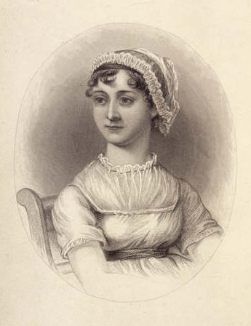

1870 engraving of Jane Austen, based on a portrait drawn by her sister Cassandra

Jane Austen was born December 16, 1775, to Rev. George Austen and the former Cassandra Leigh in Steventon, Hampshire, as the seventh of eight children. Like the central characters in most of her novels, the Austens were a large family of respectable lineage but no fortune; her father supplemented his "living" - his clergyman's income - by farming. This lively and cheerful family frequently passed their evenings in novel-reading, charades and amateur theatrics. Among her siblings, her sister Cassandra, three years older, was her lifelong friend and confidant. The abundant correspondence between the sisters provides historians with the greatest insight into Austen's past. The only undisputed portrait of Jane Austen is a somewhat rudimentary coloured sketch done by Cassandra, which currently resides in the National Portrait Gallery, London.
In 1783, Austen was educated briefly by a relative in Oxford, then in Southampton, and finally in 1785–1786 attended the Reading Ladies boarding school in the Abbey gatehouse in Reading, Berkshire. This uncommonly advanced level of education may have contributed to her early proclivity towards writing.
Her large family supplied material for the kind of novels popular when she wrote, but she chose not to draw upon any of it: her mother, for example, was related to a Duke who was master of Balliol College, Oxford; one aunt married an admiral; another, Mrs. Leigh Perrot, was falsely imprisoned for petty theft in 1799; a cousin, the Comtesse de Feuillide, fled the Reign of Terror after the execution of her husband, came to live with the Austens at Steventon, later fell in love with and married Jane's handsome and cheerful brother Henry, who later went bankrupt and then went into the Anglican priesthood; her brother James married a duke's granddaughter and followed in the path of their father and joined the clergy (the latter towards the end of his life after a successful career as a banker); her brothers Frank and Charles (who married the daughter of the Attorney-General of Bermuda) became naval officers, saw action in the Napoleonic wars, and eventually wound up admirals; and her charming and amiable brother Edward was adopted by the first family of Steventon, the Thomas Knights, a wealthy and childless couple. They educated him, sent him on the grand tour, married him to the daughter of a baronet, and made him their heir.
In 1801, Rev. Austen retired and the family moved to the socially esteemed spa city of Bath, probably so that the still-unmarried Jane and Cassandra might have a better chance of meeting marriageable men. Bath provides the setting for many of Austen’s novels.
In 1802 Austen received a marriage proposal from a wealthy but man named Harris Bigg-Wither, who was six years younger that she. Such a marriage would have freed her from some of the constraints and dependency then associated with the role of a spinster. Such considerations may have influenced her initially to accept his offer, only to change her mind and refuse him the following day. It seems clear that she did not love him.
Although she never married, Jane had several romantic liaisons, the most serious with a Rev. Blackall who died suddenly, just before they were to become formally engaged. After her father's death in 1805 the family moved to Southampton, and in 1809 her wealthy brother Edward was able to install Jane, Cassandra, and their mother in a "pretty cottage" back in Hampshire.
From 1809 on Austen lived happily with her mother and sister, her time employed in writing. In 1816, she began to suffer from ill health. In May 1817 she moved to Winchester to be closer to her doctor. It is now thought by some that she may have suffered from Addison's disease, a failure of the adrenal glands that was often caused by tuberculosis. The disease was at that time unnamed. Her condition became increasingly unstable, and on July 18, 1817 she died at the age of forty-one in Winchester, Hampshire, England and was buried in Winchester Cathedral.

