$\begin{aligned}\int{0} \text{dx}=C \\ \int{1 \text{dx}=x+C} \\ \int{x^{s}\text{dx}=\frac{x^{s+1}}{s+1}}+C \\ \int{\frac{1}{x}\text{dx}=\text{ln}\left|x\right|+C} \\ \int{e^{x}\text{dx}=e^{x}+C} \\ \int{a^{x}\text{dx}=\frac{a^{x}}{\text{ln}a}+C} \\ \int{\text{sin}x \text{dx}=−\text{cos}x+C} \\ \int{\text{cos}x \text{dx}}=\text{sin}+C \\ \int{\frac{1}{{\text{cos}}^{2}x}\text{dx}}=\text{tgx}+C \\ \int{\frac{1}{{\text{sin}}^{2}x}}\text{dx}=−\text{cot}g x+C \\ \int{\frac{1}{\sqrt{1−x^{2}}}\text{dx}=\frac{\text{arcsin}x+C}{−\text{arccos}x+C}} \\ \int{\frac{1}{1+x^{2}}\text{dx}=\frac{\text{arctgx}+C}{−\text{arc}\text{cot}\text{gx}+C}} \\ \int{\frac{f^{'}(x)}{f(x)}}\text{dx}=\text{ln}\left|f(x)\right|+C(\text{spodné} \text{zderivujem}) \\ \int{\frac{1}{a^{2}+x^{2}}\text{dx}}=\frac{1}{a}\text{arctg}\frac{x}{a}+C \\ \int{\frac{1}{\sqrt{a^{2}−x^{2}}}\text{dx}=\text{arcsin}\frac{x}{a}+C} \\ \int{\frac{1}{(x+b)^{2}+a^{2}}\text{dx}=\frac{1}{a}\text{arctg}}\frac{x+b}{a} \\ \int{u(x)\text{.}v^{'}(x)\text{dx}=u(x)\text{.}v(x)−\int{u^{'}(x)\text{.}v(x)\text{dx}}}\end{aligned}$$$\begin{aligned}(k)^{'}=0 \\ (x^{a})^{'}={\text{ax}}^{a−1} \\ (\text{sin}x)^{'}=\text{cos}x \\ (\text{cos}x)^{'}=−\text{sin}x \\ (\text{tg} x)^{'}=\frac{1}{{\text{cos}}^{2} x} \\ (\text{cot}g x)^{'}=−\frac{1}{{\text{sin}}^{2 }x} \\ (\text{ln} x)^{'}=\frac{1}{x} \\ (e^{x})^{'}=e^{x} \\ (a^{x})=a^{x }\text{ln}a \\ ({\text{log}}_{a} x)^{'}=\frac{1}{x\text{.}\text{ln}a} \\ (\text{arcsin} x)^{'}=\frac{1}{\sqrt{1−x^{2}}} \\ (\text{arccos} x)^{'}=−\frac{1}{\sqrt{1−x^{2}}} \\ (\text{arctg} x)^{'}=\frac{1}{x^{2}+1} \\ (\text{arc}\text{cot}g x)^{'}=−\frac{1}{x^{2}+1} \\ (u+v)^{'}=u^{'}+v^{'} (k\text{.}v)^{'}=k\text{.}v^{'} \\ (u−v)^{'}=u^{'}−v^{'} (u\text{.}v)^{'}=u^{'}v+uv^{'} \\ {\left(\frac{u}{v}\right)}^{′}=\frac{u^{'}v−uv^{'}}{v^{2}} \text{Sub}: u=g(x) \\ F^{'}(x)={\left[f\left(g(x)\right)\right]}^{′}=f^{'}(u)\text{.}g^{'}(x), \\ f(x)^{g(x)}=\left(g^{'}(x)\text{.}\text{ln}f(x)+\frac{g(x)\text{.}f^{'}(x)}{f(x)}\right)\end{aligned}$$

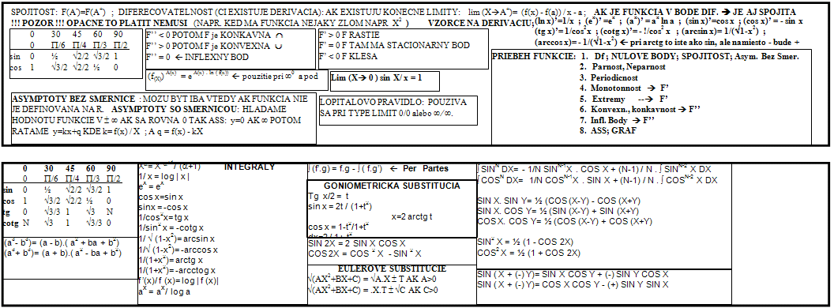

$$\begin{aligned}(k)^{'}=0 \\ (x^{a})^{'}={\text{ax}}^{a−1} \\ (\text{sin}x)^{'}=\text{cos}x \\ (\text{cos}x)^{'}=−\text{sin}x \\ (\text{tg} x)^{'}=\frac{1}{{\text{cos}}^{2} x} \\ (\text{cot}g x)^{'}=−\frac{1}{{\text{sin}}^{2 }x} \\ (\text{ln} x)^{'}=\frac{1}{x} \\ (e^{x})^{'}=e^{x} \\ (a^{x})=a^{x }\text{ln}a \\ ({\text{log}}_{a} x)^{'}=\frac{1}{x\text{.}\text{ln}a} \\ (\text{arcsin} x)^{'}=\frac{1}{\sqrt{1−x^{2}}} \\ (\text{arccos} x)^{'}=−\frac{1}{\sqrt{1−x^{2}}} \\ (\text{arctg} x)^{'}=\frac{1}{x^{2}+1} \\ (\text{arc}\text{cot}g x)^{'}=−\frac{1}{x^{2}+1} \\ (u+v)^{'}=u^{'}+v^{'} (k\text{.}v)^{'}=k\text{.}v^{'} \\ (u−v)^{'}=u^{'}−v^{'} (u\text{.}v)^{'}=u^{'}v+uv^{'} \\ {\left(\frac{u}{v}\right)}^{′}=\frac{u^{'}v−uv^{'}}{v^{2}} \text{Sub}: u=g(x) \\ F^{'}(x)={\left[f\left(g(x)\right)\right]}^{′}=f^{'}(u)\text{.}g^{'}(x), \\ f(x)^{g(x)}=\left(g^{'}(x)\text{.}\text{ln}f(x)+\frac{g(x)\text{.}f^{'}(x)}{f(x)}\right)\end{aligned}$$

