The Pilgrim Fathers

Background
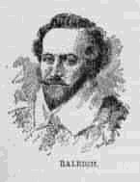 | When James I came to the throne, he adopted a moderate Protestant religious policy. Both Catholics and Puritans were forbidden to practice their religions. Many extreme Puritans left England for Holland where Puritanism was accepted.  In 1607 Walter Raleigh had founded the English colony of Virginia in America and companies had begun trading between the colony and England.

Who were they?
Thirty-five members of the radical, Puritan, English Separatist Church, who had fled to Holland to avoid persecution, were recruited by an English stock company to go to Virginia to protect their business interests. The stock company financed the venture which, when it left England, included 102 men, women and children.

The Journey
The Pilgrim Fathers set sail from Plymouth on 16th September 1620 in the 'Mayflower' captained by Myles Standish and steered a course for Virginia. The ship was a double-decked, three-masted vessel. However, a storm blew them off course and they reached land at Cape Cod which they subsequently renamed Plymouth Rock. Anchor was dropped on November 21st 1620.  They reached the site that was to become Plymouth Colony on December 21st and established their own government. |  | 
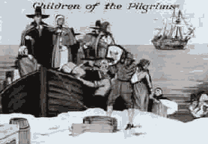
This painting shows the Pilgrim Fathers landing at Plymouth Harbour. Their ship, the Mayflower, can be seen in the distance.

December 21st is known as Forefather's Day in America.
© www.historyonthenet.com

