SLOVAKIA AND ICE HOCKEY

If someone would ask me, what is the most favourite sport in Slovakia I would probably answer ice-hockey. No other sport could unite the whole nation; no other game could provoke such great emotions like ice-hockey does. It is the reason for collective happiness or sadness. The players are treating like super-stars
Ice-hockey has the power to bring all people together, no matter if men or women, old or young - during the world championships every one is a fan.
So when the task is to speak about something that has a long tradition and what is typical for Slovakia I would probably say its ice-hockey.

History of ice hockey in Slovakia
Canada is the country widely known for introducing the game of ice hockey to the world. Although there were similar games played around the globe, Canadian ice hockey was the one to achieve dominance.
For example: bandy hockey -- a game very close to modern ice hockey and native to Europe -- was modified and later fully replaced by ice hockey. When the first European Championships took place in 1910 the game was a mixture of elements of both bandy and ice hockey. The difference between the two was mainly the rules and the equipment used by players. Bandy hockey used shorter sticks and the protective equipment was also rather modest. The Canadian form of the game had fully replaced the other variations on the European continent during the Olympic Games in Chamonix in 1924. Bandy hockey was number one in Slovakia, too.
In 1908, the International Ice Hockey Federation, an international organization that still runs most of the international hockey tournaments today, was established. In Slovakia (as a part of former Czechoslovakia), Canadian Ice Hockey was popularized during the European Championships in High Tatras in 1925.

The year 1929 is the milestone of the ice hockey in Slovakia, when the first volume of the Tatra Cup (the second oldest tournament in Europe - after the Spengler Cup in Switzerland) was organised in Starý Smokovec. Two days later, on January 31st, 1929, the first Slovak hockey organisation was established under the name of “Slovenská župa kanadského hokeja” as a part of the Czechoslovak Ice Hockey Federation.
The founding members were Ski klub Bratislava, ŠK Slávia Banská Bystrica, ŠK Vysoké Tatry, ČsŠK Košice and ŠK Žilina. So the hockey finally got its "mother" organisation in Slovakia and this date is considered as the initial day of history of ice hockey in Slovakia.
The first organised competition, The Slovak Championship, was launched already in 1930 and the first Slovak team managed to fight its way to the National Czechoslovak Hockey League in 1936. It was the HC Tatry. The university club VŠ Bratislava became the second participant the following year.
The first Slovak player included into the Czechoslovak National Team was Ladislav Troják, player of HC Košice. In 1934 he left for Prague to play for LTC Praha, one of the best hockey clubs in Czechoslovakia those times. That was a springboard to the representation team for him. Neither did he staid away from the Team Czechoslovakia at the Winter Olympic Games in Garmisch-Partenkirchen in 1936, where the representation selects ended up on the 4th place. However the clouds of fascism and the World War II had already been flying over the Europe then.
After the disintegration of Czechoslovakia in 1938 and during the time of establishment of Separate Slovak State the “Slovenská župa kanadského hokeja” changed to the Slovak Ice Hockey Federation and the first Slovak National Team resulted from that change. The Slovak representation selects played 10 international games with the balance of 3 wins, 2 ties and 5 losses in period between 1940 and 1943. In the country under the High Tatras ice hockey was generally enjoyed by public, particularly where the natural conditions were suitable. Banská Bystrica, for example, was one of such towns and had the largest number of players representing Slovakia.
The Slovak Ice Hockey Federation became a part of the Czechoslovak Ice Hockey Federation after the World War II and four Slovak teams (ŠK Bratislava, VŠ Bratislava, ŠK Banská Bystrica, HC Vysoké Tatry) participated to the restored national competition.
The first post-war World Championship was played in Prague in 1947 and Team Czechoslovakia again also consisted of Ladislav Troják, who unfortunately died at the air crash over the La Manche together with 5 other members of National Team. It was his fifth championship. Matej Buckna, Slovak of Canadian origin was a Head Coach of the National Team.
Many more Slovak teams like VŠ Bratislava, ŠK Banská Bystrica, Žilina, Poprad (for 5 seasons) were introduced to the national competition during the first decade after the World War II. Only the HC Slovan Bratislava, where the best hockey players (also from villages) started to assemble, managed to hold their permanent place there. It was particularly their contribution to arise the number of the Slovak players in the National Team during the 50-ties.
Bratislava hosted the world hockey elite in 1959. One group of the World Championship was played there. Canadian National Team enjoyed great interest together with the Team Czechoslovakia. The cradle of ice hockey was represented by the club Belleville McFarlands. It was them (Czechoslovakia and Canada), who were promoted to the final round played in Prague. That championship had an enormous share on the further popularisation and development of ice hockey in Slovakia

The best known Slovak players
There are many others who also made Slovakia famous for ice hockey around the world. Some examples are:
- Matej Buckna, as already said a Canadian coach of Slovak origin, helped to develop ice hockey in Czechoslovakia.
- Vladimír Dzurilla, a goalkeeper who helped Czechoslovakia to achieve a number of remarkable international triumphs and a player of an older generation.
- Ján Starší, highly respected coach and team manager, also from an older generation.
Similar to the Czech Republic, Slovakia is internationally considered to be a breeding ground for talented players, many of whom are playing in the best leagues in the world, of which the NHL is the most prestigious.
- Peter Bondra
- Zdeno Chára
- Pavol Demitra
- Marián Gáborík
- Michal Handzuš
- Marcel Hossa
- Marián Hossa
- Milan Jurčina
- Stan Mikita
- Ladislav Nagy
- Žigmund Pálffy
- Miroslav Šatan
- Anton Šťastný
- Marián Šťastný
- Peter Šťastný
- Jozef Stümpel
- Marek Svatoš
- Róbert Švehla
- Ľubomír Višňovský
- Richard Zedník
Czechoslovakia and its successor states are rated as being among the leading nations on the international scene, thanks to their triumphs in the Winter Olympic Games and the World Championships.
However, the Slovak national team had to face a difficult challenge in 1993 after its separation of Czechoslovakia. According to the IIHF regulations it had to compete with countries with little or no ice hockey tradition at all to prove being worthy to compete at the highest level. Many ice hockey experts and journalists found this rather humiliating for Slovakia. It has since found its way all the way back to the top. Within only a few years of independent existence as a young nation it would mark its biggest triumph ever by winning the world championships in Sweden in 2002.

Slovak Hockey Hall of Fame

Now a few words about the Slovak Hockey Hall of Fame. The Slovak Hockey Hall of Fame (Sieň slávy slovenského hokeja) was installed in November 30, 2002 in the year when the national team of Slovakia won the IIHF World Championships gold medal. The Hall is located in Bratislava, Slovakia.

[]The members of the Slovak Hockey Hall of Fame:
Since 2002
Ladislav Troják, Stan Mikita, Michal Polóni, Ladislav Horský, Ján Starší, George Gross, Vladimír Dzurilla, Jozef Golonka, Václav Nedomanský, Peter Šťastný
Since 2003
Rastislav Jančuška, Vojtech Okoličány, Miroslav Červenka, Ján Jendek
Since 2004
František Gregor, Karol Fako, Vincent Lukáč, Milan Kužela
Since 2005
Jaroslav Walter, Igor Liba

“Big Moments”

Here are some of the biggest moments in the history of the best Slovak players at the world championships:

1965
VLADIMÍR DZURILLA – best goalkeeper (najlepší brankár)
1992
RÓBERT ŠVEHLA – best defender (najlepší obranca)
2000
MIROSLAV ŠATAN – best forwarder (najlepší útočník)
2002
MIROSLAV ŠATAN – scoring leader (najproduktívnejší hráč)

LINKS:

http://en.wikipedia.org/wiki/History_of_ice_hockey_in_Slovakia

http://en.wikipedia.org/wiki/Slovak_Hockey_Hall_of_Fame

http://www.szlh.sk/english/history-of-slovak-hockey

http://www.sienslavy.sk/historia

http://www.sienslavy.sk/historia/naj-okamihy

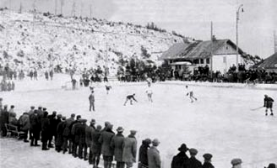

Starý Smokovec in the 1920s

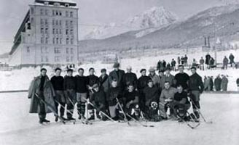

LTC Praha & Ski klub Bratislava

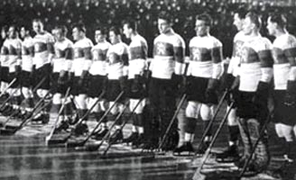

The team of the ČSR in 1949

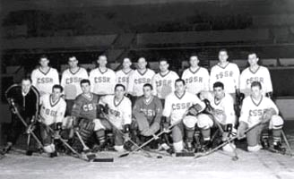

The team of the ČSSR in 1963

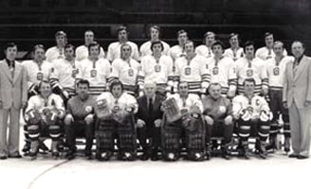

The team of the ČSSR at the Ice Hockey World Championships 1977
In Vienna, Austria

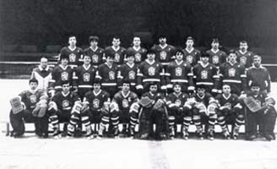

The team of the ČSSR – world champions of 1985

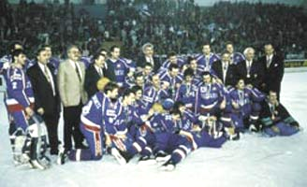

The golden team of Slovakia at the Ice Hockey World Championships 1994
Category C

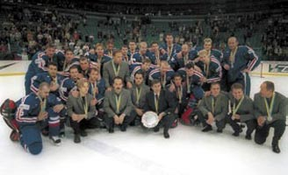

The team of Slovakia at the Ice Hockey World Championships 2000
In Petrograd, Russia – silver

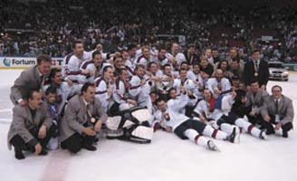

The team of Slovakia at the Ice Hockey World Championships 2002
In Göteburg, Sweden – gold

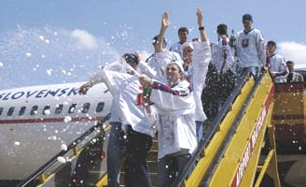

The arrival of the “golden boys” at the air port of M.R. Stefanik in 2002

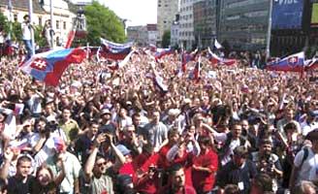

The welcoming for the “golden boys” in Bratislava at the square of SNP

